Matrix population models
Useful reading= Caswell 2001, matrix population modelling
Sensitivity= how changes in transition rate affect lambda.
Elasticity= how changes in vital rate affect lambda (calculated with popdemo)
Fundamentals in calculation:
Model plan
- Creating simple MPM with 1 set of pop vital rates, project
- Sex specifics, then project
- Add density dependence that adjusts vital rates based on pop size prev year
- Envir covariates? – annual min temp, habitat suitability, summer rainfall ?
- Projections- extinction risk in next 100 years,
- Spatial- immigration, emigration, some distance metric.
- Comparison= anova metric differences due to density. Extinction risk?

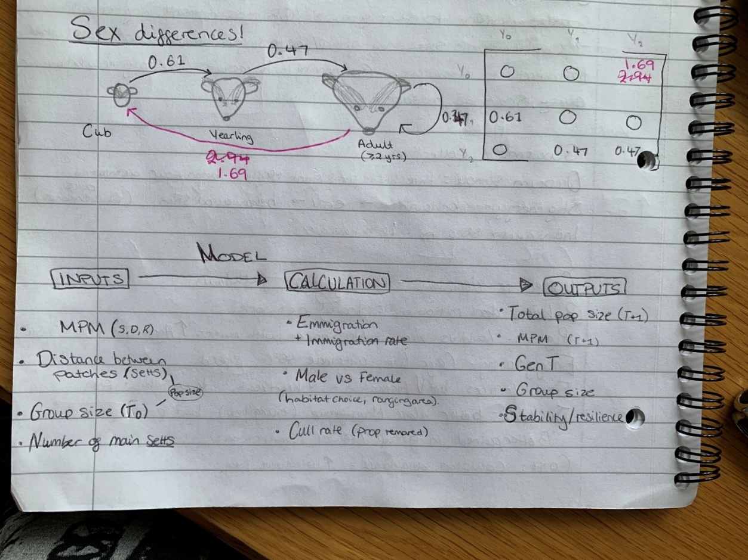
Ex Basic MPM for badgers

Age of reproduction = 2 years

Limitations of my model
Simplifies reproductive patterns (decline in females over time, first reproduction at 4).
Very few badgers reproduce after 9 years old = post-breeding stage?

Construction
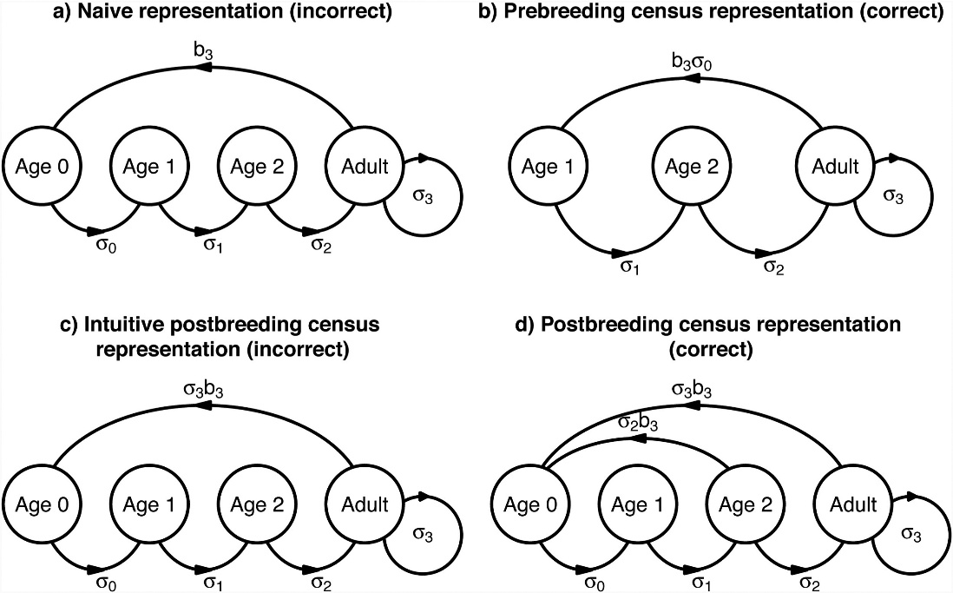
Where age at reproductive maturity= 3 years.
Badgers are birth-pulse= have a breeding (birthing) season. Breeding and births as instantaneous- one day a year n cubs produced. Pre-breeding= pop monitoring one day before, post-breeding = 1 day after.
Birth rate= ‘average number of offspring produced at time t by an individual that is alive at time t.’
Including survival in fertility coefficient- f. f= survival* birth. Pre= cub survival, post= juvenile or adult survival

Fecundity = number of offspring produced per adult (can be per adult f or m)
Fertility= per capita rate of contribution one stage to the next over one year, so that survival included to appear in the next stage.
Must convert fecundity rates to fertility rates for use in matrix [1]

Population trends
Projection= vector multiplication T_{x+1}= PT_{x} OR T_{x}= PT^{x} P= matrix with vital rates T₀= Initial structure by stage

Data
Badgers of Wytham Woods, Chpt 11, table 11.7: Survival rates for males and females by age. Also net reproductive rates equation
Ages: 0-1, 1 (yearling), 2+ (adult at breeding age), elderly needed? (decrease in reproduction)
Cub and yearling values taken direct from table, while adult values averaged- issues?. Data comes from only known age individuals- DON’T NEED KNOWN AGE as only using classes which can be observed from raw data
Cub (<1 yr), growth rates = 1-death rate. Do not remain cubs
Yearling (<2 yrs) , growth = from table. Do not remain yearlings
Adult (>=2 yrs), survival = average 2-8 survival, growth= 9 survival
Cub and yearling easy to age, adults aged by tooth wear, uncertainty so best to group together.
Could combine cub production and survival to first year as recruitment rate
age at 1st reproduction, α, remained consistently (and inflexibly) at 2 years of age- Macdonald 2009
Spatial info- MoveBank badger movement data
Survival rates from mortality data

2 sex model
2 sex model limitations- info on male reproductive rates
Males mature at 1, females 2 (Male yearlings reproductively mature) Bright Ross 2020
Fig 11.13 in Wytham book- example 2 sex MPM. Cubs are considered asexual

Spatial element
Movement equations: Exeter models- email for permissions to reuse?
Male badger movement by age class- Macdonald 2008
Movebank data?
Density impacts on immigration and emigration + av distance from sett per day?
Compare metrics for different scenarios, compare pop projections (ancova, diff demographic points based on )
Factors affecting dispersal=
Not diffusion (no net difference in densities)
Group density
No. females in group increases male movement
Females = increase movement at high density pops
Distance

1. Fujiwara, M., & Diaz-Lopez, J. (2017). Constructing stage-structured matrix population models from life tables: comparison of methods. PeerJ 5, e3971.

